**DAILY ONLINE ACTIVITIES SUMMARY**

|  |  |  |  |  |  |  |  |  |
| --- | --- | --- | --- | --- | --- | --- | --- | --- |
| **Date:** | **29-05-2020** | | | | | **Name:** | **Preethi** | |
| **Sem & Sec** | **6th - B** | | | | | **USN:** | **4AL17CS065** | |
| **Online Test Summary** | | | | | | | | |
| **Subject** | | **Operation Research** | | | | | | |
| **Max. Marks** | | **30** | | **Score** | | | **30** | |
| **Certification Course Summary** | | | | | | | | |
| **Course** | **Introduction to Information Security** | | | | | | | |
| **Certificate Provider** | | | **greatlearning** | | **Duration** | | | **5.5 hours** |
| **Coding Challenges** | | | | | | | | |
| **Problem Statement:1 C, 1 Python and 3 Java program** | | | | | | | | |
| **Status: executed** | | | | | | | | |
| **Uploaded the report in GitHub** | | | | | **Yes** | | | |
| **If yes Repository name** | | | | | <https://github.com/PreethiNayak/Daily-Status/tree/master/29May2020> | | | |
| **Uploaded the report in slack** | | | | | **Yes** | | | |

Online Test Details: (Attach the snapshot and briefly write the report for the same)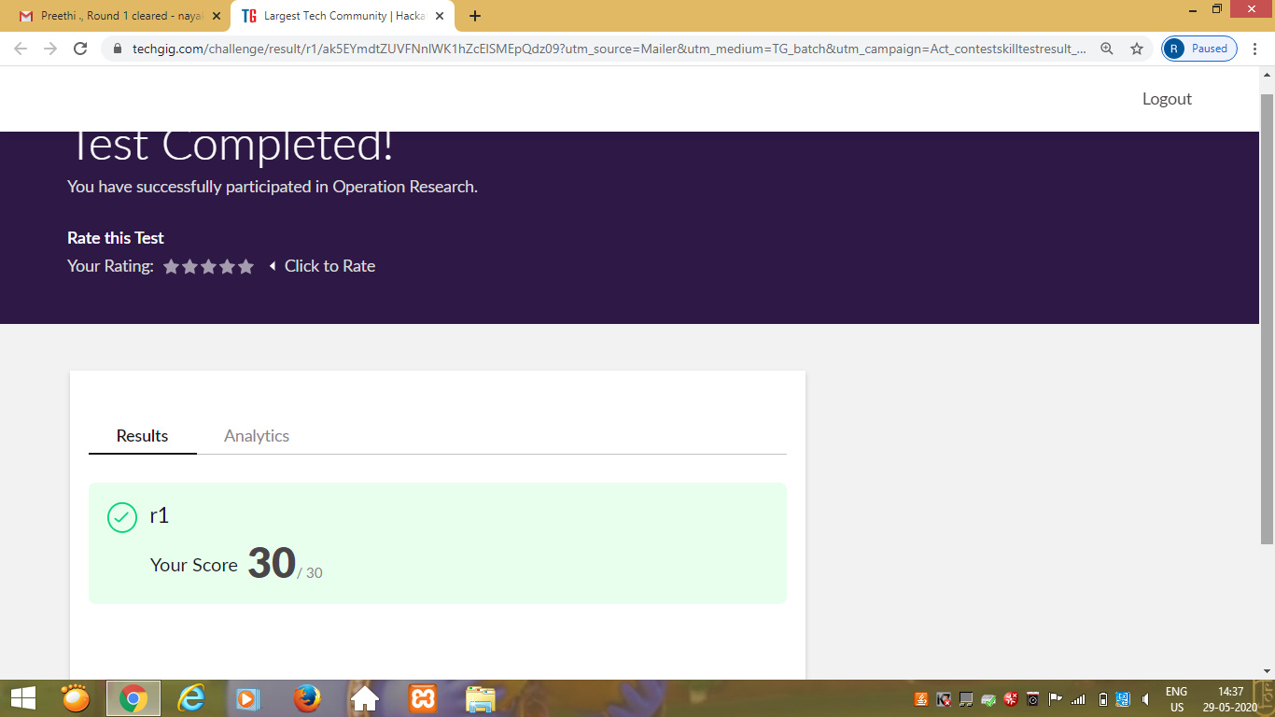

Certification Course Details: (Attach the snapshot and briefly write the report for the same)

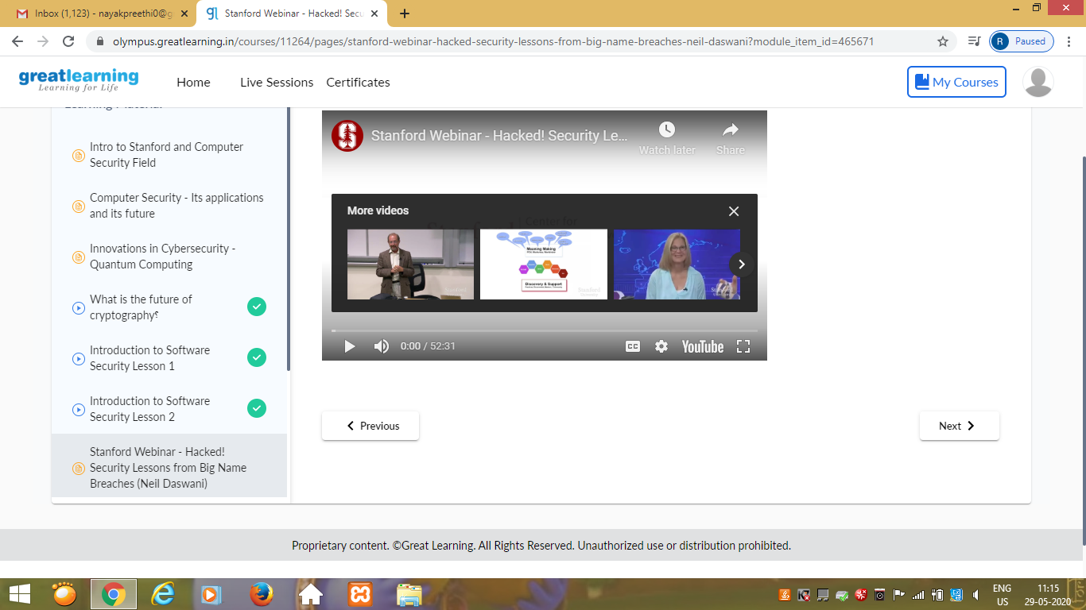

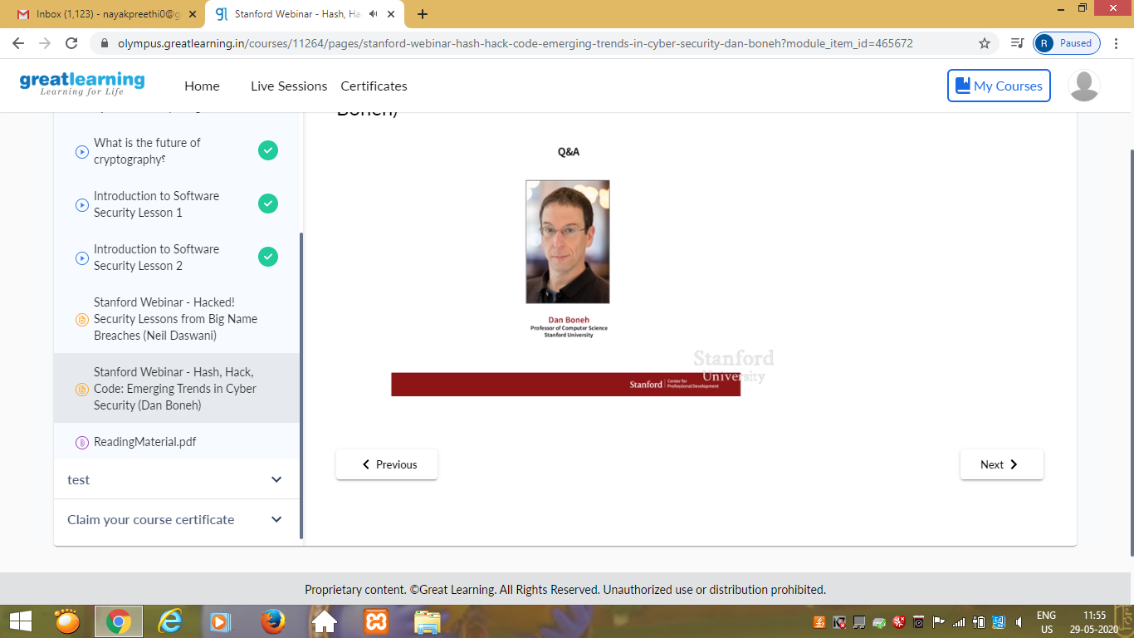

Today I attended webinar by Stanford Faculty.In that I learnt,

1)Security lessons from Big Name Breaches(Neil Daswani)

2)Emerging trends in cyber security(Dan Boneh)

Coding Challenges Details: (Attach the snapshot and briefly write the report for the same)

Program 1

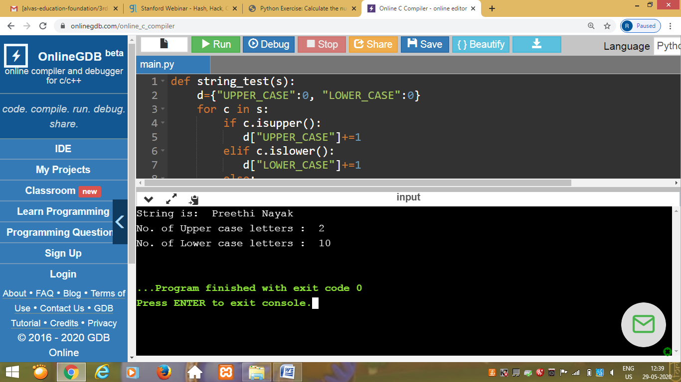

This is output of python program to find the number of uppercase and lowercase letters in the given string in the program.

Program 2

This is the output of the java program that detects whether string3 is a valid shuffle of string1 and string2.

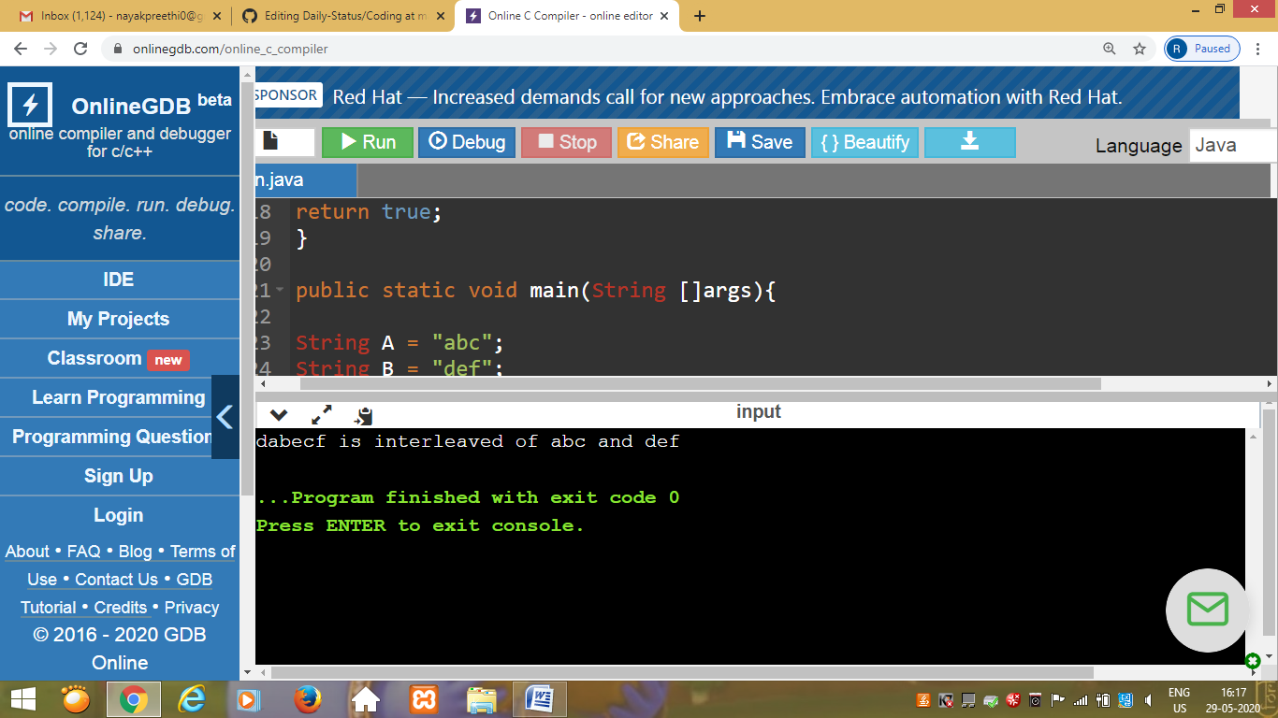

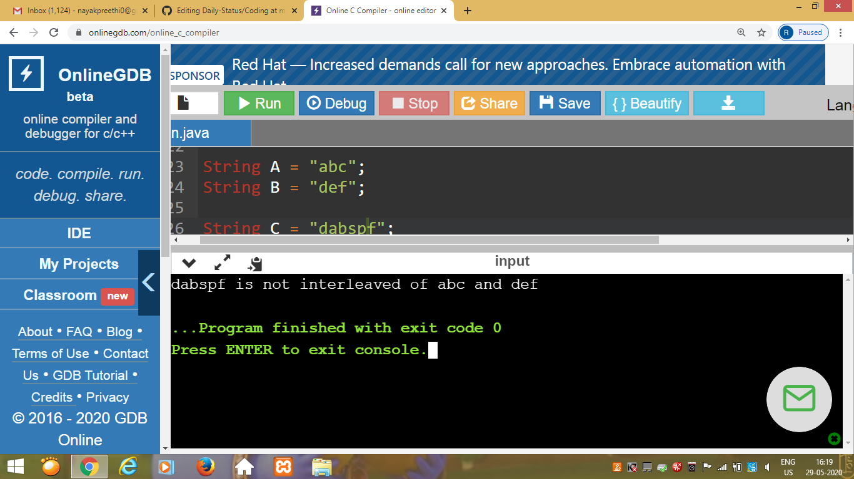

Program 3

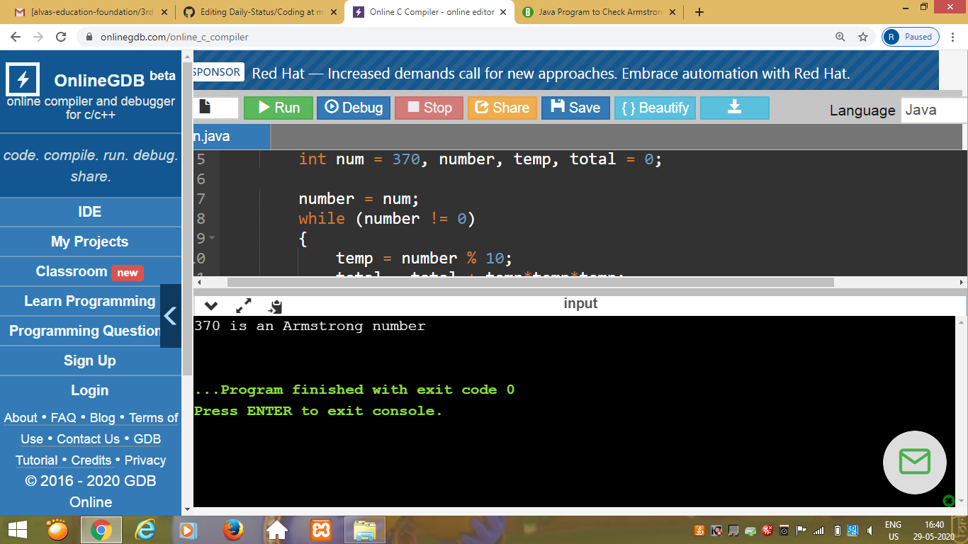

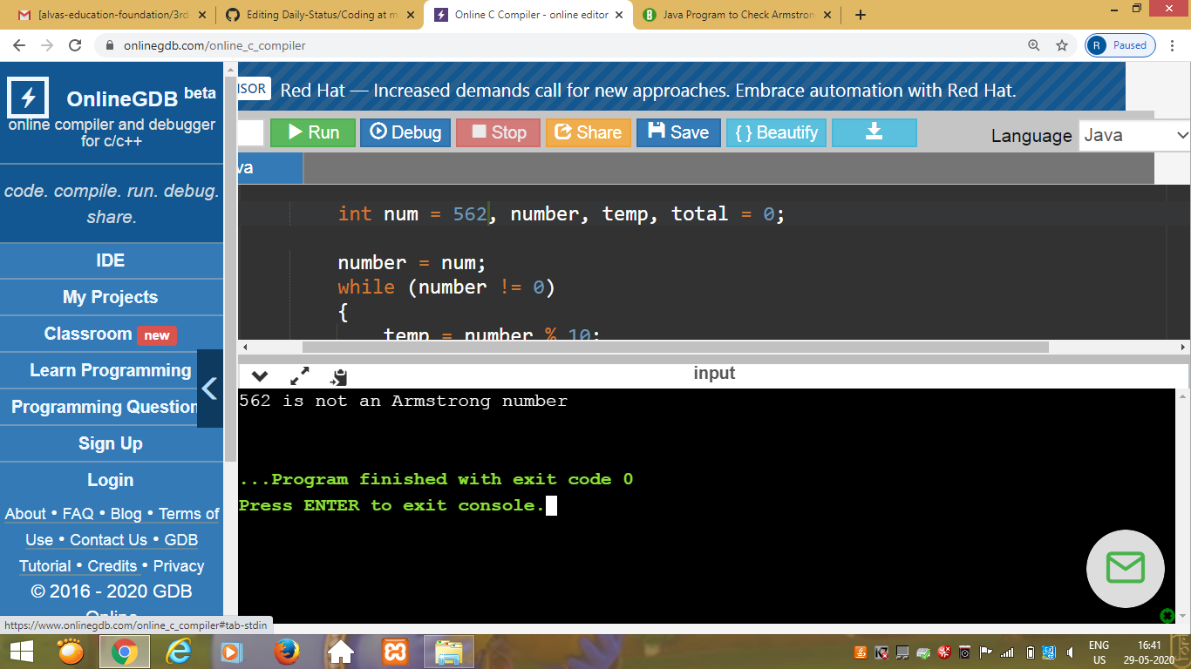

This is the output of java program to display whether given number is Armstrong number or not.

Program 4

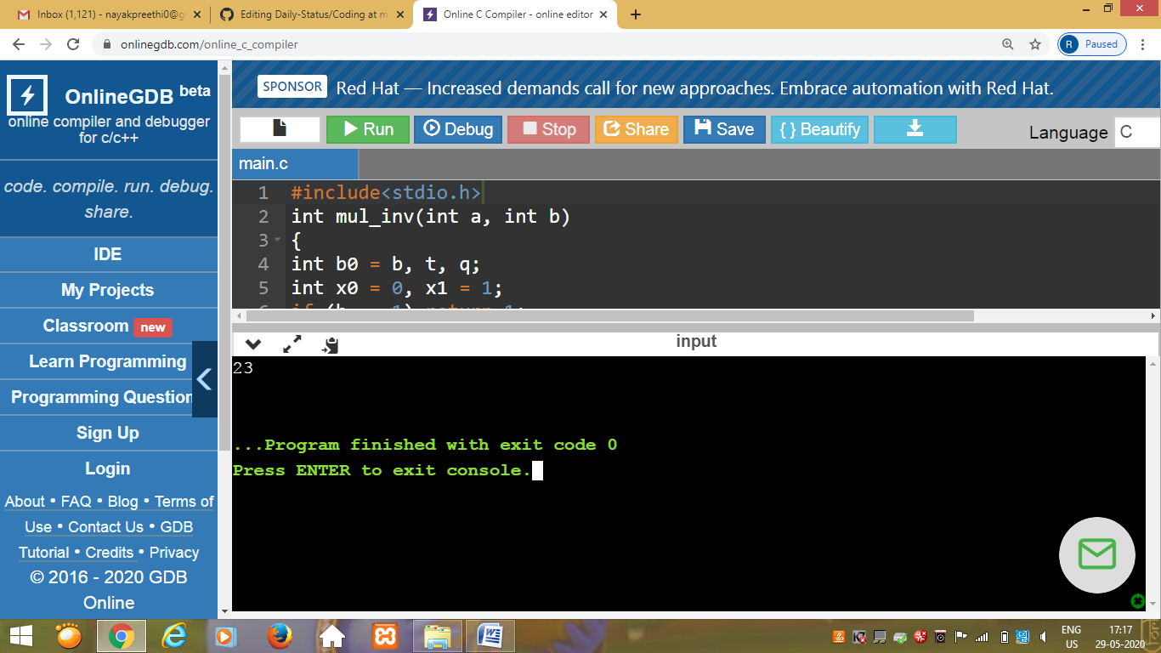

This is the output of C program to solve a system of linear congruences by applying the Chinese Remainder Theorem.

Program 5

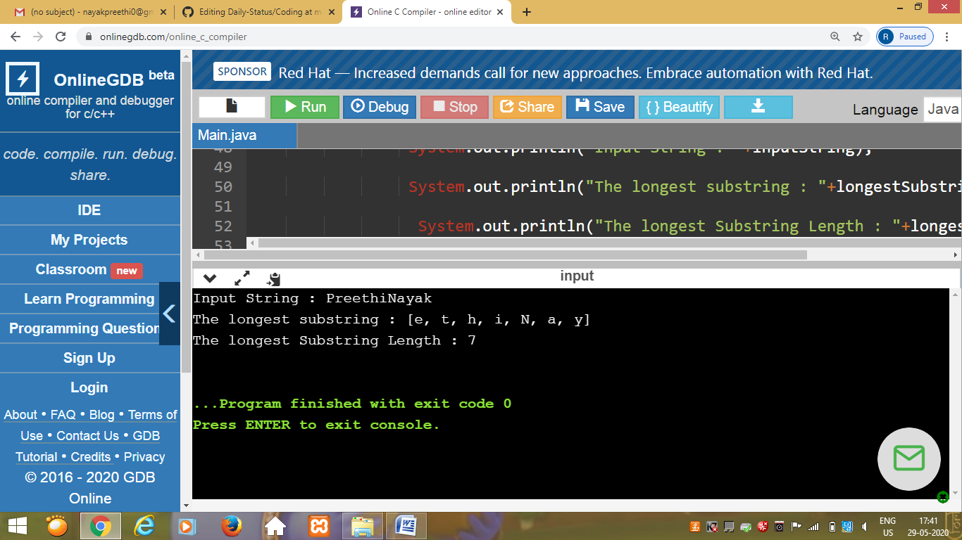

This is output of the program to find longest substring without repeating characters in a string.